FOUNDER'S LETTER
A LETTER FROM THE FOUNDER
Title: Building the Memory of the Intelligence Age
We live in a paradoxical era. We generate more data in a single day than our ancestors did in a century, yet our ability to preserve this truth is more fragile than ever. The "Information Age" gave us access, but it did not give us permanence.
As we transition into the Intelligence Age, dominated by Artificial Intelligence and Autonomous Economies, the ephemeral nature of data becomes an existential risk. If an AI model forgets its history, it hallucinates. If a financial ledger loses its past, it collapses.
For over a decade working in Information Technology, I have witnessed the limitations of centralized architectures. They are efficient, yes, but they require us to trust fallible custodians. In the world of Bitcoin and Decentralized Finance, "Trust" is a bug, not a feature.
Strata Protocol is born from a simple yet radical question: Can we build a digital memory that is as immutable as the laws of physics?
We believe the answer lies in the convergence of Modular Blockchains and Bitcoin. We do not seek to build "just another storage coin." We are engineering a Bitcoin Extension Block that functions as a Sovereign Digital Vault - anchored by the thermodynamic energy of Bitcoin, scaled by the modularity of Celestia, and powered by a global network of physical hardware.
This Whitepaper is not merely a technical specification; it is a blueprint for the infrastructure of truth. We invite you to join us in building the hard drive for the next century of human innovation.
Sincerely,
Nguyen Binh Minh (Assoc. Prof. Dr.) Founder, Strata Protocol

LEGAL DISCLAIMER
The information set forth in this Whitepaper may not be exhaustive and does not imply any element of a contractual relationship. Nothing in this Whitepaper constitutes an offer to sell or a solicitation of an offer to buy any securities, commodities, or other financial instruments in any jurisdiction.
Not Financial Advice: The content of this document is for informational purposes only and should not be construed as financial, legal, or tax advice. Potential contributors should consult their own advisors.
Forward-Looking Statements: This document contains forward-looking statements regarding Strata Protocol's roadmap, financial projections, and technical goals. These statements are subject to risks and uncertainties that could cause actual results to differ materially.
Token Classification: The $STRAT token is designed as a cryptographic utility token ("Work Token") required to utilize the Strata Network. It is not intended to constitute a security, unit in a business trust, or collective investment scheme.

TECHNICAL WHITEPAPER: STRATA PROTOCOL
ABSTRACT
The transition from the Information Age to the Intelligence Age has precipitated an exponential demand for decentralized, verifiable, and permanent data storage. However, the current Web3 infrastructure faces a critical "Storage Trilemma": existing solutions are either prohibitively expensive (monolithic blockchains), structurally fragile due to endogenous security dependencies (legacy storage networks), or fragmented from the world’s most liquid asset class—Bitcoin.
STRATA PROTOCOL introduces a paradigm shift as the first Bitcoin Extension Block for Data Availability.. By decoupling consensus, data availability, and physical storage, Strata engineers a "Sovereign Digital Vault" designed for the permanence of high-value assets, including Artificial Intelligence datasets, Real-World Asset (RWA) records, and Bitcoin Layer-2 states.
Our architecture advances beyond the limitations of "Endogenous Security"—where network safety is circularly dependent on a volatile native token. Instead, Strata leverages Exogenous Security via Babylon, importing the thermodynamic finality of the Bitcoin Proof-of-Work ledger to secure its Proof-of-Stake consensus. This creates a security floor mathematically anchored to the trillion-dollar economic weight of the Bitcoin network, rendering "Long-Range Attacks" and data censorship economically irrational.
Simultaneously, Strata integrates Celestia for Data Availability Sampling (DAS), allowing the network to scale throughput linearly with the addition of DePIN light nodes. This modular approach reduces hardware barriers, fostering a permissionless, global marketplace of physical storage providers.
Underpinned by a Burn-and-Mint Equilibrium (BME) and a Progressive Reputation Model, Strata aligns long-term incentives between storage providers and capital allocators. We present not merely a storage protocol, but a foundational layer for the decentralized economy—where data is as immutable as Bitcoin itself.

SECTION 1: INTRODUCTION
1.1. The Macro Context: From the Information Age to the Intelligence Age
We are standing at the precipice of a civilizational shift. The last two decades—the Information Age—were defined by the aggregation of user-generated content and the digitization of analog records. Today, we are entering the Intelligence Age, defined by the proliferation of Generative AI, autonomous agents, and high-frequency machine-to-machine commerce.
In this new epoch, data is no longer merely content; it has evolved into Existential Data—information so critical that its loss implies systemic collapse.” it has become the fundamental "truth source" for trillions of dollars in automated economic activity.
- Large Language Models (LLMs) require petabytes of immutable, tamper-proof datasets to prevent "hallucinations" and malicious bias (Data Poisoning).
- Real-World Assets (RWAs) tokenized on-chain require permanent, legally admissible historical records to maintain their valuation.
- Bitcoin Layer-2 Ecosystems require a scalable ledger to store transaction history without bloating the main chain.
However, a critical gap exists in the Web3 stack. While we have perfected Trustless Computation (Ethereum, Solana) and Trustless Money (Bitcoin), we have failed to establish Trustless Memory. The current decentralized storage landscape is fragmented, expensive, and structurally fragile.
1.2. The Problem Statement: The Storage Trilemma
To understand why a new architecture is necessary, we must first analyze the structural failures of existing solutions. The decentralized storage market is currently trapped in a "Storage Trilemma," unable to simultaneously achieve: (1) Cost Efficiency, (2) Linear Scalability, and (3) Exogenous Security.
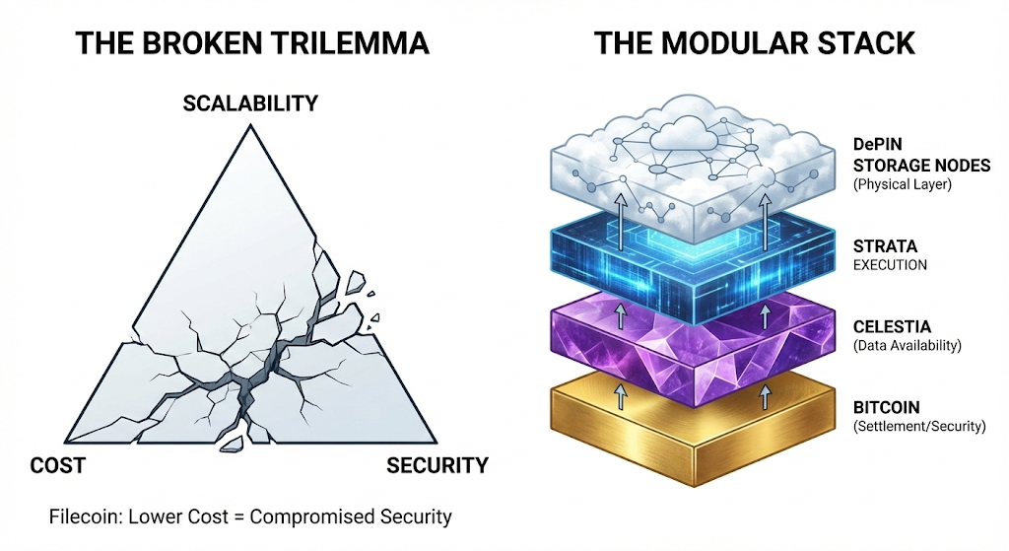
Figure 1.2: The Broken Trilemma vs. The Modular Stack
A. The Monolithic Cost Wall
Monolithic blockchains (e.g., Ethereum Mainnet, Bitcoin Core) are engineered for high-security execution, not high-volume storage.
- The Economics: Storing 1 GB of data on Ethereum creates a permanent burden on every full node in the network. Consequently, the market price for on-chain storage creates an insurmountable barrier for data-intensive applications.
- The "Pruning" Reality: To survive, these chains must aggressively prune (delete) historical data. This renders them unsuitable for archival purposes, forcing developers to rely on centralized Web2 servers (AWS/Google Cloud), reintroducing the very centralization risks Web3 aims to eliminate.
B. The "Reflexivity Trap" of Endogenous Security
Legacy decentralized storage networks (Gen 1 & Gen 2) suffer from a fatal flaw in their cryptoeconomic design: Endogenous Security.
- The Mechanism: The security of the stored data relies entirely on the value of the network's native token.
- The Risk: In a "Reflexivity Trap" (a concept formalized by George Soros), a decline in token price leads to a decline in miner profitability, which leads to node capitulation, which further degrades network security, causing the price to crash further.
- The Institutional Verdict: Major institutions cannot insure trillion-dollar assets (e.g., Tokenized Real Estate, National Archives) on a network where security evaporates if the token price drops by 90% during a crypto winter.
C. The Bitcoin Gap
Bitcoin represents over 50% of the entire crypto industry's liquidity and is the only asset class universally recognized as a commodity. Yet, the Bitcoin network remains an "isolated island."
- The exploding ecosystem of Bitcoin L2s, Ordinals, and BRC-20 standards has created a massive demand for data availability.
- Currently, these protocols must resort to bridging data to external, less secure chains or relying on centralized indexers. There is no native "Data Layer" that inherits Bitcoin’s security without spamming the Bitcoin block space.
1.3. The Solution Paradigm: The Bitcoin Extension Block
Strata Protocol is not merely a "storage sidechain"; it functions architecturally as a Bitcoin Extension Block.
- The Concept: Just as the human brain requires a cortex to store memories that the brainstem cannot process, Bitcoin requires an external layer to store complex data (L2 history, RWA records) without bloating its scarce 4MB block limit.
- The Mechanism: By anchoring state roots via Babylon, Strata effectively expands Bitcoin's utility surface area without altering its consensus rules. We are the "Hard Drive" physically welded to the "CPU" of Bitcoin.
- Investment Thesis: We do not compete with generic storage chains; we compete for the hegemony of the Bitcoin Economy's infrastructure.
Strata Protocol is not a mere iteration of existing storage networks; it is a fundamental architectural divergence. We introduce the first Modular DePIN Storage Network anchored by Bitcoin.
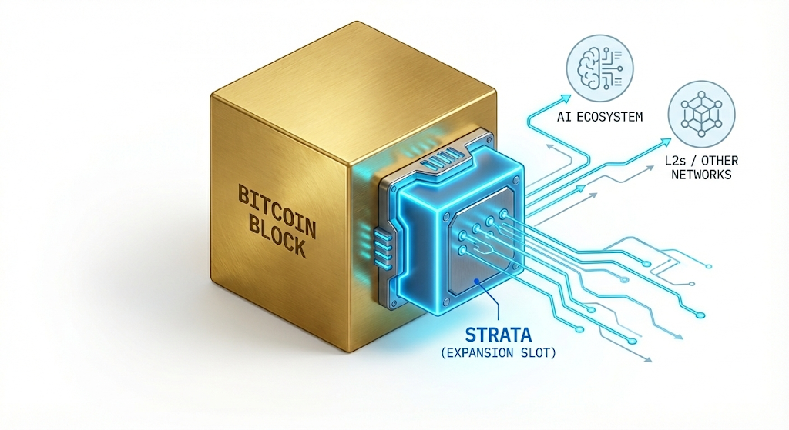
Figure 1.3: The solution Paradigm – Strata as an Integral Bitcoin Expansion
Our design philosophy rests on three pillars:
Pillar 1: Exogenous Security via Bitcoin (The "Gold Standard")
Strata decouples Utility from Security.
- Instead of relying solely on the $STRAT token, we leverage Babylon to import security from the Bitcoin network.
- Strata validators checkpoint block headers onto the Bitcoin Proof-of-Work chain. To reverse a transaction or censor data on Strata, an attacker must expend the energy required to reorganize the Bitcoin blockchain itself.
- Result: This achieves Thermodynamic Finality, creating a security floor that remains unbreakable even if the Strata token price fluctuates.
Pillar 2: Modular Scalability via Celestia (The "Infinite Hard Drive")
Strata rejects the monolithic approach. We integrate Celestia as the Data Availability (DA) layer.
- Using Data Availability Sampling (DAS), Strata allows light nodes to verify data integrity without downloading the entire chain.
- Result: The network’s throughput scales linearly with the number of nodes. As more hardware joins the network, the network becomes faster and cheaper—the opposite of monolithic congestion.
Pillar 3: The DePIN Economy (The "Physical Layer")
Strata democratizes the physical storage layer.
- We utilize a Burn-and-Mint Equilibrium (BME) model combined with Progressive Reputation Staking.
- This creates a permissionless marketplace where anyone with a hard drive can contribute storage and earn yield, while ensuring "Skin-in-the-game" to prevent malicious behavior.
1.4. The Vision: The Sovereign Vault
Strata Protocol is engineered to be the "Long-term Memory" of the Crypto Economy. We are building the infrastructure where:
- Bitcoin L2s offload their transaction history for permanent, verifiable archiving.
- AI Agents retrieve immutable datasets to verify the provenance of their knowledge.
- Humanity preserves its most critical digital artifacts in a vault secured by the laws of thermodynamics, not just code.

SECTION 2: SYSTEM ARCHITECTURE
2.1. The Modular Stack Philosophy
Strata Protocol rejects the legacy "World Computer" monolithic architecture, where a single network attempts to handle execution, settlement, data availability, and storage simultaneously. Such architectures inevitably face the "Scalability Trilemma," resulting in network congestion and prohibitive costs.
Instead, Strata adopts a Modular Architecture, orchestrating a specialized stack of protocols to achieve optimal performance. The Strata Network functions as the Extension Layer, binding together the security of Bitcoin, the data availability of Celestia, and the physical storage of the DePIN network.
2.1.1. The Four-Layer Stack
The Strata architecture is composed of four distinct layers:
- Execution Layer (Strata App-Chain):
  - Built on the Cosmos SDK, utilizing CometBFT for instant finality ($<2s$ block time).
  - Handles the logic of the Storage Marketplace, File Metadata index, and the Dual-Token economy ($STRAT & Data Credits).
- Settlement Layer (Bitcoin via Babylon):
  - Provides thermodynamic finality. Strata checkpoints are anchored to the Bitcoin blockchain, ensuring that any attempt to rewrite Strata’s history requires reorganizing Bitcoin itself.
- Data Availability Layer (Celestia):
  - Ensures that the transaction data and state transitions of the Strata chain are published and retrievable.
  - Utilizes Data Availability Sampling (DAS) to allow light clients to verify chain integrity without downloading full blocks.
- Physical Storage Layer (DePIN):
  - A decentralized network of permissionless nodes that store the actual encrypted data shards (payloads).
  - Secured by Proof-of-Spacetime (PoSt) and Reputation-based Staking.
2.1.2. The "Modular Abstraction" Defense
A critical risk in modular stacks is "Dependency Lock-in." To mitigate this, Strata implements Abstracted Interfaces for all external dependencies.
- Interchangeability: The Protocol is not hard-coded to Celestia or Babylon. It connects via generalized API standards (e.g., the DA-Adapter Interface).
- Future-Proofing: Should a provider fail or become economically extractive, Strata Governance can vote to hot-swap the underlying layer (e.g., migrating DA from Celestia to EigenDA or Avail) without disrupting the Application Layer. This ensures Strata retains Sovereign Control over its supply chain.
2.2. Consensus: Bitcoin-Secured Proof-of-Stake
Strata implements a hybrid consensus model designed to import the economic security of Bitcoin into a Proof-of-Stake (PoS) environment.
2.2.1. The Babylon Anchoring Mechanism (Detailed Flow)
Strata leverages Babylon to attain Bitcoin-equivalent finality without requiring a soft fork of the Bitcoin protocol. This is achieved through a BLS-based Checkpointing mechanism utilizing the OP_RETURN opcode.
- Step 1: BLS Signature Aggregation: At the end of a Strata Epoch (defined as $N$ blocks), the Validator set reaches consensus on the canonical chain tip. Instead of individual signatures, Validators sign the Epoch Checkpoint using BLS12-381 signature scheme. This allows the protocol to aggregate $n$ signatures into a single, constant-size multi-signature ($σ_{agg}$), ensuring the payload fits within Bitcoin's block constraints.
- Step 2: The OP_RETURN Submission: A specialized Anchor Node (Submitter) constructs a standard Bitcoin transaction. The payload is embedded in the transaction output using the OP_RETURN opcode, structured as follows:
OP_RETURN <Tag: STRATA_CKPT> <Epoch_ID> <BlockHash_Hash> <BLS_Sig>
  - Note: The data footprint is minimized to $< 80$ bytes to ensure standard propagation across the Bitcoin mempool.
- Step 3: The "K-Deep" Finality Rule: Strata nodes run an integrated Bitcoin Light Client (SPV). The Strata fork-choice rule is modified to prioritize the chain tip referenced by the most recent Checkpoint that is buried under $k$ Bitcoin blocks (typically $k=6$).
  - Implication: Once a Strata block is "Babylon-finalized," creating a conflicting history would require a 51% attack on the Bitcoin network itself to reorganize the OP_RETURN transaction. This provides Strata with the highest level of thermodynamic security available in the industry.
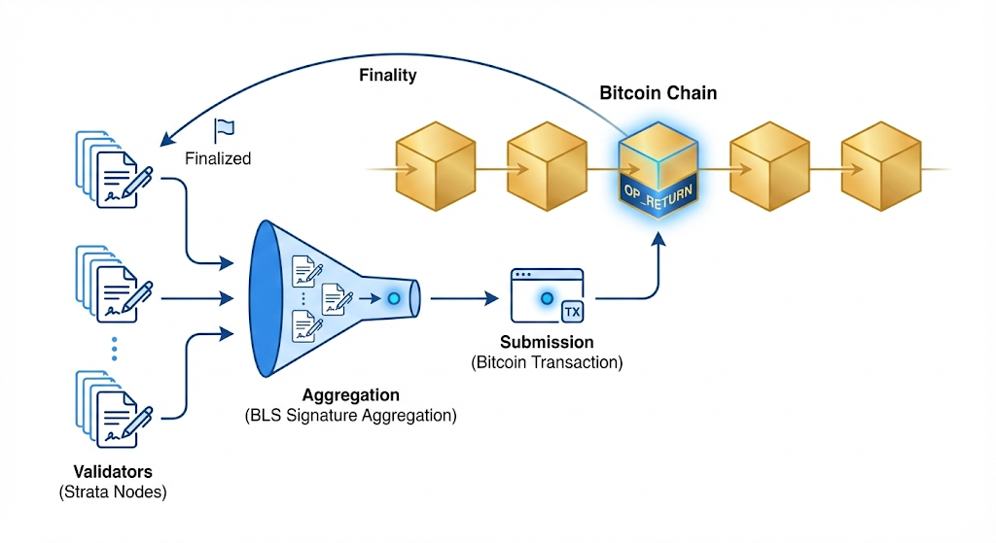
Figure 2.2: The Babylon Anchoring Flow
2.2.2. Slashing via Extractable One-Time Signatures (EOTS)
A critical challenge in Bitcoin Staking is enforcing "slashing" (punishment) on a blockchain that lacks smart contracts (Bitcoin is not Turing-complete). Strata solves this using EOTS.
- The Mechanism: When a Validator signs a block on Strata, they use an EOTS key pair.
- The Trap: If a Validator acts maliciously (e.g., double-signing two conflicting blocks at the same height), the mathematical properties of EOTS allow their private key to be extracted from the two conflicting signatures.
- The Punishment: An automated "Watchtower" service detects the key leakage and submits a slashing transaction to the Bitcoin network, burning the Validator's staked BTC.
- Security Implication: This creates a verifiable Cost of Corruption (CoC). An attacker cannot simply buy $STRAT tokens to attack the network; they must risk their precious BTC.
2.3.3. Latency Mitigation: Optimistic Pre-Confirmations
While Strata relies on Bitcoin for thermodynamic finality (which takes ~60 minutes), modern applications require millisecond-level responsiveness. To bridge this gap, Strata implements a Dual-Finality Gadget:
- Soft Finality (Instant): Utilizing the CometBFT consensus engine, Strata Validators provide "Optimistic Pre-Confirmations" with a block time of < 2 seconds.
  - Mechanism: Once a transaction is included in a Strata block and signed by >2/3 of the validator set, it is considered "Soft Finalized."
  - User Experience: Users receive immediate confirmation of their uploads/transfers, mimicking the responsiveness of Web2 cloud services.
- Hard Finality (Asynchronous): In the background, these pre-confirmed blocks are batched and anchored to Bitcoin via Babylon.
  - Security Guarantee: Even if the Strata validator set attempts to revert a Soft Finalized block, the "Hard Finality" on Bitcoin serves as the immutable source of truth, creating a slashable offense for any malicious reorganization attempts.
2.3. The Data Availability (DA) Layer
To serve as the storage layer for high-throughput applications (AI, L2s), Strata must process millions of transactions per second without bloating the validator nodes. We achieve this via Celestia.
2.3.1. Blobstream Integration
Strata integrates Blobstream (formerly Quantum Gravity Bridge) to stream data commitments from Celestia to the Strata Execution Layer via IBC (Inter-Blockchain Communication).
- Step 1: Strata aggregators batch transaction data into "Blobs."
- Step 2: These blobs are posted to Celestia. Celestia validators do not execute the transactions; they strictly order them and guarantee availability.
- Step 3: Strata Light Clients verify the data availability using Data Availability Sampling (DAS).
2.3.2. Namespaced Merkle Trees (NMTs)
Strata utilizes Celestia’s NMTs to partition data.
- Applications building on Strata (e.g., a specific AI project) can download only the data relevant to their specific "Namespace" (AppID) without processing the entire Strata ledger.
- Result: This reduces the computational load on indexers by orders of magnitude compared to monolithic chains like Ethereum.
2.4. The Physical Storage Engine: Erasure Coding & Redundancy
While Celestia handles the chain data (proofs and metadata), the payload data (the actual files, videos, datasets) is stored on the Strata DePIN Layer. We employ an industrial-grade Redundancy Algorithm to ensure 99.99999% durability.
2.4.1. Mathematical Formalization of Reed-Solomon Sharding
To achieve thermodynamic durability with optimal storage overhead, Strata implements a Systematic Reed-Solomon ($RS$) coding scheme over a Finite Field via a Vandermonde-based Generator Matrix.
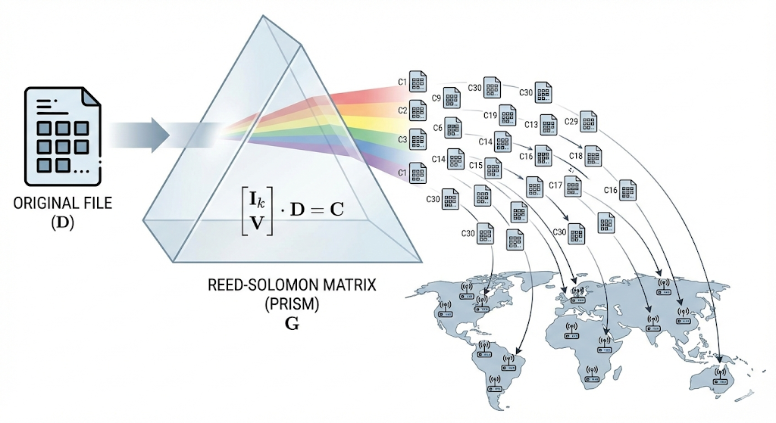
Figure 2.4.1: Reed-Solomon Matrix & Sharding
A. Field Definition
All arithmetic operations within the Strata encoding engine are performed over the Galois Field $GF\left(2^{8}\right)$. This field is constructed using the irreducible primitive polynomial:
$P\left(x\right)=x^{8}+x^{4}+x^{3}+x^{2}+1$
This choice of $GF\left(2^{8}\right)$ allows for efficient byte-level operations, ensuring compatibility with standard hardware instruction sets (AVX2/AVX-512) for high-performance encoding.
B. Encoding via Vandermonde Matrix
Let the input data payload be represented as a vector $D=\left(d_{0},d_{1},…,d_{k-1}\right)$, consisting of $k$ data symbols.
We define a code $\left(n,k\right)$ where $n$ is the total number of shards produced ($n > k$). The parity symbols $m = n - k$ serve as the redundancy layer.
The encoding process is a linear transformation defined by the matrix multiplication:
$C=G⋅D$
where:
- $C={\left(c_{0},c_{1},…,c_{n-1}\right)}^{T}$ is the output codeword vector containing $n$ shards.
- $G$ is the $n ×k$ Generator Matrix.
To ensure the "Systematic" property (where the first $k$ output shards are identical to the input data for zero-latency retrieval), the Generator Matrix $G$ is constructed as:
$Ⅎb\{G\} = 〖\{bmatrix\} Ⅎb\{I\}_k \backslash \backslash Ⅎb\{V\} 〗\{bmatrix\}$
Here, $I_{k}$ is the $k ×k$ Identity Matrix, and $V$ is an $m ×k$ Vandermonde Matrix defined by evaluation points $α_{i}$ within the Galois Field:
$V_{i,j}=α_{i}^{j} for 0≤i<m,0≤j<k$
This algebraic structure guarantees that any sub-matrix formed by $k$ rows of $G$ is invertible (non-singular). Consequently, the original data $D$ can be perfectly reconstructed from any subset of $k$ shards retrieved from the network.
C. Durability Probability Function
Strata’s redundancy model allows us to mathematically quantify the probability of permanent data loss ($P_{loss}$).
Let $p$ be the independent probability of a single node failure (or malicious churn) within a specific epoch. The probability that the network fails to recover a file (i.e., fewer than $k$ shards survive) is given by the cumulative Binomial Distribution:
$P_{loss}=\sum_{i=0}^{k-1}{}\left(\frac{n}{i}\right){\left(1-p\right)}^{i}p^{n-i}$
Strategic Configuration: for high-value archival data (Tier-1 Assets), Strata defaults to a schema of $n=30, k=10$. Assuming a conservative node failure rate of $p = 0.1$ (10% of nodes go offline simultaneously), the probability of data loss is:
$P_{loss}≈1.8×{10}^{-14}$
This result yields a durability of 14 nines (99.999999999999%), vastly exceeding the durability standards of centralized cloud providers (AWS S3 offers 11 nines) while utilizing significantly less storage bandwidth than traditional 3x Replication.
2.4.2. Data Ingestion Flow (The "Upload Lifecycle")
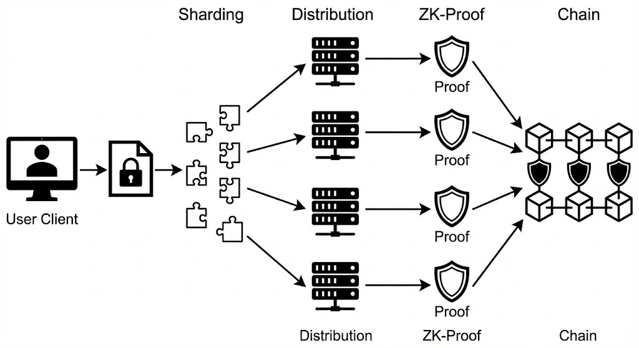
Figure 2.4.2: Data Ingestion Flow
- Encryption: The User Client encrypts the file locally using AES-256-GCM.
- Tessellation: The file is passed through the Reed-Solomon engine, generating 30 shards.
- Selection: The Strata Network selects 30 distinct storage nodes based on:
  - Geolocation Diversity (preventing regional outages).
  - Reputation Score (high uptime).
  - Collateral Status (sufficient stake).
- Distribution: Shards are transmitted to nodes via IPFS/P2P transport.
- Commitment: Nodes sign a receipt and generate a ZK-Proof confirming storage. This proof is aggregated and posted to the Strata Chain.
2.5. Inter-Blockchain Communication (IBC) & Bridges
Strata is designed to be "Chain Agnostic" despite being secured by Bitcoin.
- IBC Native: As a Cosmos SDK chain, Strata connects natively to the Interchain ecosystem (Cosmos, Osmosis, dYdX) via IBC.
- Hyperlane Integration: Strata implements Hyperlane to facilitate permissionless bridging of data requests from EVM chains (Ethereum, Arbitrum, Base) and SVM (Solana).
- Bitcoin L2 Adapters: Strata provides specialized SDKs for Bitcoin Rollups (e.g., Merlin, Stacks) to write state roots directly to Strata, acting as their modular DA/Storage layer.

SECTION 3: THE DePIN STORAGE LAYER
3.1. Node Taxonomy & Heterogeneous Architecture
Unlike homogeneous blockchain networks where every node performs identical tasks, Strata implements a Heterogeneous Topology. The physical infrastructure is divided into specialized roles to optimize for the distinct requirements of storage density (Capacity) vs. data retrieval speed (Bandwidth).
3.1.1. Storage Nodes (The "Vaults")
These are the backbone of the Strata network, responsible for long-term retention of encrypted shards.
- Primary Function: Storing Reed-Solomon encoded shards and generating zk-PoSt proofs.
- Hardware Requirements (Enhanced Specification):
  - CPU: Modern multi-core processor with AVX-512 support (required for high-performance Erasure Coding).
  - Accelerator (Optional but Incentivized): Support for CUDA-enabled GPUs (NVIDIA) or FPGAs.
    - Strategic Utility: While currently used to accelerate zk-PoSt proof generation (reducing proving time by 10x vs. CPU), this hardware requirement positions Strata nodes to offer Decentralized Compute services (e.g., AI Inference, ZK-Rollup Proving) in future protocol upgrades (Phase 4).
  - Storage: Enterprise-grade HDD (CMR) with >10TB capacity per node.
- Economic Role: Earns block rewards ($STRAT) proportional to storage committed and tenure.
3.1.2. Retrieval Nodes (The "Edge Accelerators")
These nodes act as a decentralized Content Delivery Network (CDN). They cache "Hot Data" (frequently accessed files) to ensure low-latency retrieval for AI agents and L2 sequencers.
- Primary Function: Serving data requests and providing bandwidth.
- Hardware Requirements:
  - Storage: High-speed NVMe SSDs (Gen 4/5).
  - Network: 1Gbps - 10Gbps symmetric fiber connection.
- Economic Role: Earns yield in $STRAT via the protocol's settlement layer. User payments (in Data Credits) for bandwidth are routed through the Liquidity Vortex to execute buybacks before being distributed to nodes.
- The "AI-Ready" Certification: Not all Retrieval Nodes are equal. To serve Tier-1 AI Clients, Retrieval Nodes must stake additional $STRAT to acquire the "AI-Ready" Status.
  - Requirement: Must be hosted in Tier-3 Data Centers with verified <20ms latency to major cloud hubs (AWS us-east-1, GCP europe-west1).
  - Privilege: Exclusive rights to cache and serve high-value AI Training Datasets (High volume, high bandwidth fees).
  - Penalty: Subject to "Latency Slashing" if response time drops below the SLA threshold during random checks.
3.1.3. Validator Nodes (The "Watchtowers")
- Primary Function: Ordering transactions, verifying ZK-proofs submitted by Storage Nodes, and managing the Babylon bridge.
- Constraint: Must run a full Celestia Light Node to perform Data Availability Sampling (DAS).
3.2. Zero-Knowledge Proof-of-Spacetime (zk-PoSt) Mechanism
To guarantee data retention without compromising privacy or bloating the verification layer, Strata implements a custom zk-SNARK circuit based on the Groth16 proving system utilizing Poseidon as the arithmetization-friendly hash function.
3.2.1. Circuit Arithmetization: Rank-1 Constraint System (R1CS)
The computational integrity of storage is reduced to a set of arithmetic constraints over a finite field $F_{r}$, where $r$ is the scalar field order of the BN254 elliptic curve.
We define the storage proof program as an arithmetic circuit transformed into a Rank-1 Constraint System (R1CS). For a witness vector $w$ (containing private data shards) and a public input vector $x$ (containing Merkle roots and challenges), the R1CS is satisfied if and only if:
$⟨a_{i},z⟩⋅⟨b_{i},z⟩=⟨c_{i},z⟩ ∀i∈\{1,…,m\}$
where:
- $z=\left(x,1,w\right)$ is the concatenated state vector.
- $a_{i},b_{i},c_{i}$ are coefficient vectors defining the logic gates (constraints).
- $⟨⋅, ⋅⟩$ denotes the inner product.
- $m$ is the total number of constraints in the circuit.
Optimization: Strata replaces the standard SHA-256 hash in the Merkle Tree construction with Poseidon Hash. Since Poseidon is designed specifically for $GF\left(p\right)$ arithmetic, it reduces the constraint count per hash from $∼25,000$ (SHA-256) to $< 300$ constraints. This yields a 80x reduction in proof generation time for Miners.
3.2.2. The Non-Interactive Protocol (Fiat-Shamir Heuristic)
The proving process is made non-interactive using the Fiat-Shamir transformation, ensuring that Miners can submit proofs asynchronously without a live challenge-response session with Validators.
Let $R$ be the relation defining valid storage:
$R=\{\left(\dot{rt},pos,v\right);\left(path,data\right):MerkleVerify\left(\dot{rt},pos,path,data\right)=1\}$
Step 1: Commitment - The Miner constructs a Merkle Tree of the stored shards. The root $\dot{rt}$ is committed to the Strata Chain.
Step 2: Deterministic Challenge Generation - Instead of receiving a random query from a validator, the challenge $ρ$ is derived cryptographically from the current block header hash $H_{block}$ and the Miner's ID:
$ρ=Poseidon\left(H_{block}∥MinerID∥EpochID\right)$
The challenge $ρ$ determines the specific leaf indices $idx_{1},…,idx_{k}$ that the Miner must prove possession of.
Step 3: Proof Generation ($π$) - The Miner calculates the witness $w=\left(path,data\right)$ for the challenged indices and generates the SNARK proof $π$ using the Proving Key ($PK$):
$π←Prove\left(PK,x,w\right)$
where public input $x=\left(\dot{rt},ρ\right)$.
3.2.3. Verification via Bilinear Pairings
On the Validator side (Strata Chain), verification must be constant-time $O\left(1\right)$ regardless of the dataset size. We utilize Bilinear Pairings on elliptic curve groups $G_{1}$ and $G_{2}$.
The proof $π=\left(A,B,C\right)$ is valid if and only if the following pairing equation holds:
$e\left(A,B\right)=e\left(α,β\right)⋅e\left(L\left(x\right),γ\right)⋅e\left(C,δ\right)$
where:
- $e:G_{1}×G_{2}→G_{T}$ is the efficient bilinear map (Tate or Ate pairing).
- $α, β, γ, δ$ are toxic waste parameters from the Trusted Setup (Phase 2), encoded in the Verification Key ($VK$).
- $L\left(x\right)$ is the linear combination of public inputs encoded on the curve.
Performance Metrics:
- Proof Size: Constant at $∼128$ bytes (extremely succinct, negligible on-chain storage cost).
- Verification Time: $< 10$ milliseconds per proof.
3.3. Reputation System & Proof-of-Physical-Work
While zk-Proofs verify that data exists, the Reputation System verifies that the service quality meets enterprise standards. This is the "Proof-of-Physical-Work" aspect, ensuring nodes are not just storing data but are reliable, fast, and geographically distinct.
3.3.1. The Scoring Algorithm
Every Storage Node is assigned a dynamic Reputation Score ($R_{score}$) updated every epoch. The score determines the node's eligibility to receive high-value data shards (Tier-1 Assets) and the multiplier for their block rewards.
The scoring function is defined as:
$R_{score}\left(t\right)=\left(w_{1}⋅\frac{U\left(t\right)}{U_{max}}+w_{2}⋅\frac{1}{L\left(t\right)}+w_{3}⋅loglog \left(T\left(t\right)\right) \right)⋅I_{collateral}$
where:
- $U\left(t\right)$ - Uptime Consistency: The ratio of successful proof submissions over the last $N$ epochs. Missing a proof slashes $U\left(t\right)$ exponentially.
- $L\left(t\right)$ - Latency (Ping): The average response time to random "Heartbeat" challenges sent by regional Edge Nodes. Lower latency yields a higher score.
- $T\left(t\right)$ - Tenure (Age): A logarithmic function of the node's age. This prevents "Churn Attacks" (where malicious actors constantly spin up new nodes). Older, stable nodes are trusted more.
- $I_{collateral}$ - Collateral Coefficient: A binary or step function indicating if the node has met the Progressive Staking requirements. If Collateral < Minimum, then $R_{score}→0$.
3.3.2. Tiered Storage Classes
Based on $R_{score}$, nodes are categorized into classes:
- Iron Tier ($R_{score}<50$): Can only store redundant copies (parity shards) and "Cold" data. Low rewards.
- Gold Tier ($R_{score}>80$): Eligible for primary data shards and high-frequency retrieval data. High rewards.
- Diamond Tier ($R_{score}>95$ + Full Collateral): Eligible for RWA and Financial Data storage. Maximum yield + Revenue Share from protocol fees.
3.4. Sybil Resistance & Geolocation
To prevent a single entity from simulating thousands of nodes (Sybil Attack) to control the network, Strata employs IP-Intelligence and Hardware Fingerprinting.
- Hardware Fingerprinting: The mining software generates a unique ID based on the UUID of the Motherboard and CPU Serial Number. Two nodes running on the same physical machine (Virtual Machines) are detected and banned.
- Geo-Fencing: The shard distribution algorithm ensures that the 30 shards of a single file are never sent to the same IP subnet or the same ASN (Autonomous System Number). This guarantees that even if an entire data center goes offline (e.g., AWS East-1 outage), the file remains recoverable from other nodes globally.

SECTION 4: CRYPTOECONOMICS
4.1. The Efficiency Thesis: Modular Leverage
Strata Protocol fundamentally rejects the capital-intensive model of legacy storage networks (e.g., Filecoin, Arweave), which required hundreds of millions of dollars in CapEx to bootstrap proprietary consensus layers. Instead, Strata leverages the Modular Stack to achieve extreme capital efficiency.
- Zero-Overhead Infrastructure: By outsourcing security to Bitcoin (via Babylon) and Data Availability to Celestia, Strata reduces protocol maintenance costs by ~90%.
- Capital Allocation: Every dollar of raised capital is directed toward Liquidity Bootstrapping and User Acquisition, not reinventing consensus mechanisms.
- Dual-Token Structure: To operationalize this efficiency, the economy is separated into two distinct assets:
  - Data Credits (DC): A stable unit of account (pegged to USD) for predictable enterprise payments.
  - $STRAT: The productive network asset used for staking, collateral, and value capture.
4.2. Value Capture: The "Liquidity Vortex" (Enhanced BME)
To maximize token value retention with a tighter capital base, Strata implements the "Liquidity Vortex"—an aggressive variation of the standard Burn-and-Mint Equilibrium (BME) model.
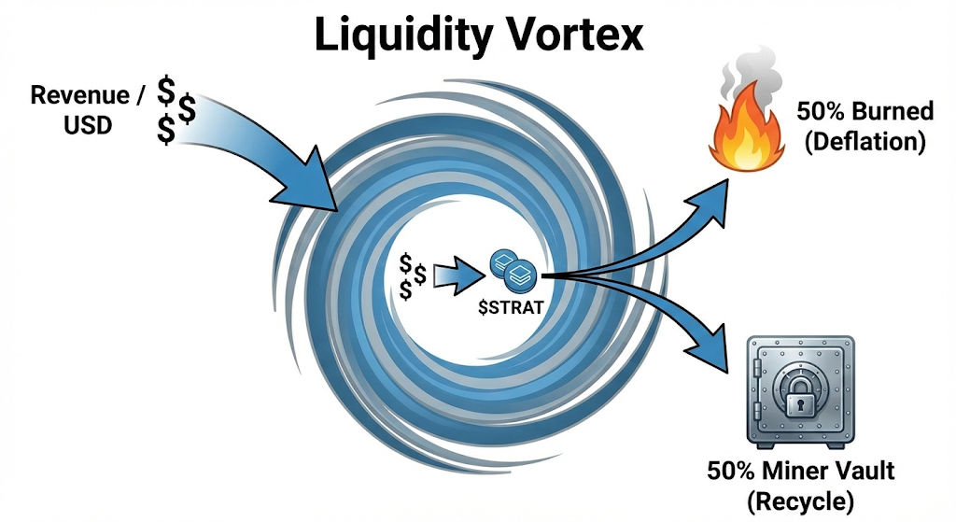
Figure 4.2: Value Capture
4.2.1. The Equilibrium Equation
The fundamental value of the network is governed by the equilibrium condition where Value Burned equals Value Minted:
$P_{eq}=\frac{D_{t}}{M_{t}}$
where $D_{t}$ is Network Revenue (Demand) and $M_{t}$ is Token Emission (Supply).
4.2.2. The 100% Revenue Recycling Protocol
Unlike protocols that accumulate idle treasuries, Strata enforces a strict 100% Revenue Buyback policy. All Data Credit revenue is programmatically routed to a DEX smart contract to market-buy $STRAT, executing a split strategy:
- 50% Burned: Permanently removed from supply (Deflationary pressure).
- 50% Recycled: Deposited into the "Miner Incentive Vault" to supplement future block rewards.
  - Strategic Advantage: This extends the protocol's runway without needing to mint new inflationary tokens, creating a self-sustaining economy faster than competitors.

4.2.3. The Stabilization Reserve Fund (SRF)
To mitigate the volatility inherent in pure BME models, Strata implements an algorithmic damper known as the Stabilization Reserve Fund (SRF).
- The Mechanism: Instead of blindly burning 50% of revenue, the protocol calculates a Dynamic Burn Rate ($β$) based on the deviation of the token price from a target moving average.
- Function:
  - In Overheated Markets: The protocol reduces the burn rate and diverts excess revenue into the SRF. This prevents a "Supply Shock" that could make entry costs prohibitive for new miners.
  - In Bear Markets: The SRF deploys capital to support miner rewards, ensuring network security is maintained even when organic revenue dips.
- Result: This transforms $STRAT from a volatile crypto-asset into a stabilized commodity currency, suitable for long-term enterprise contracts.
- "Initialization: To ensure stability from Genesis, the SRF is pre-seeded with 5% of the Ecosystem Fund allocation, providing immediate support capacity prior to organic revenue accumulation."
4.3. Valuation Framework: Velocity Control & Supply Squeeze
Traditional valuation models ($MV = PQ$) fail to account for the "Lock-up" mechanics of DePIN. Strata introduces the Collateral Multiplier to quantify the "Supply Squeeze."
4.3.1. The Extended Equation of Exchange
We adapt the valuation formula to account for Effective Velocity ($V_{effective}$):
$P_{token}=\frac{Q}{M_{circ}⋅V_{base}⋅\left(1-α\right)}$
where $α$ is the Staking Ratio (percentage of supply locked). In Strata, $α$ is not static; it is driven by the Dynamic Collateral Ratio ($λ$).
4.3.2. The Dynamic Collateral Mechanism
Miners are required to pledge collateral ($C$) proportional to the data they store.
$C_{required}=λ⋅R_{mining}$
- Low Usage: $λ= 0.5$ (Low barrier to entry).
- High Usage: As blocks fill up, $λ$ increases to $2.0$.
- Investment Implication: This creates a Positive Feedback Loop. As network revenue grows, miners are mathematically forced to buy and lock more tokens to capture that revenue.
Higher Revenue $→$ Higher Collateral Demand $→$ Lower Velocity $→$ Higher Token Price.
4.4. Incentive Alignment: The "Vampire Attack" & Earn-to-Stake
Strata employs a "Vampire Attack" strategy combined with an Earn-to-Stake model to siphon capacity from legacy networks.
4.4.1. The "Vampire Attack" Strategy
The Strata Client is designed to run in parallel on existing Filecoin/Arweave hardware.
- Zero Switching Cost: Strata requires no heavy "Sealing" process (thanks to Reed-Solomon), reducing electricity costs by 80%.
- Profitability Arbitrage: Miners earn higher Net Profit on Strata even at lower revenue levels, driving organic hardware migration with zero CapEx from the Foundation.
4.4.2. Earn-to-Stake (Progressive Collateral)
To solve the "Cold Start Problem" for new miners:
- Entry Bond: Miners join with minimal capital (e.g., 5% bond).
- Auto-Compounding: 70% of block rewards are automatically re-staked into the miner’s Collateral Vault until the target ratio is met.
  - Result: The network builds its own security budget organically from Proof-of-Physical-Work.
The "Proof-of-Burn" Dashboard: To ensure absolute financial transparency for token holders, the Liquidity Vortex is coupled with a public Real-Time Telemetry Dashboard.
- On-Chain Verification: Every Buyback-and-Burn transaction is executed via an immutable smart contract. The dashboard tracks:
  - Total Revenue (DC) Ingested.
  - Real-time $STRAT Burn Rate.
  - Current Deflationary Pressure (Burn vs. Emission delta).
- Investor Impact: This transforms the token valuation model from "Speculative" to "Quantifiable." Analysts can calculate the exact P/E (Price-to-Earnings) ratio of the protocol at any second, establishing Strata as a fundamental asset class similar to dividend-paying equities.
4.5. Unit Economics & Sustainability Analysis
We project a rapid path to sustainability based on superior Unit Economics. By removing the "Sealing" overhead, Strata fundamentally alters the Return on Invested Capital (ROIC) for storage providers.
Table 4.5: Unit Economics
Metric | AWS S3 (Centralized) | Filecoin (Legacy Web3) | Strata Protocol (Modular)
OpEx Basis | High (Power + Cooling + Staff) | High (GPU Sealing + ZK Compute) | Low (Idle HDD Power only)
CapEx Efficiency | Medium | Low (Requires High-RAM + GPU) | Maximal (Commodity Hardware)
Price to User | ~$23 / TB / Month | ~$5 / TB / Month (Subsidized) | ~$4 / TB / Month (Real Yield)
Capital Efficiency Ratio (CER) | N/A | 0.2x ($1 CapEx generates $0.20/yr) | 0.8x ($1 CapEx generates $0.80/yr)
Break-Even Point | N/A | Year 4-5 | Month 14-18 (Projected)
Analysis: Strata achieves a 4x higher Capital Efficiency Ratio than legacy decentralized competitors. This allows miners to remain profitable even at lower price points, creating a defensive moat against price wars.
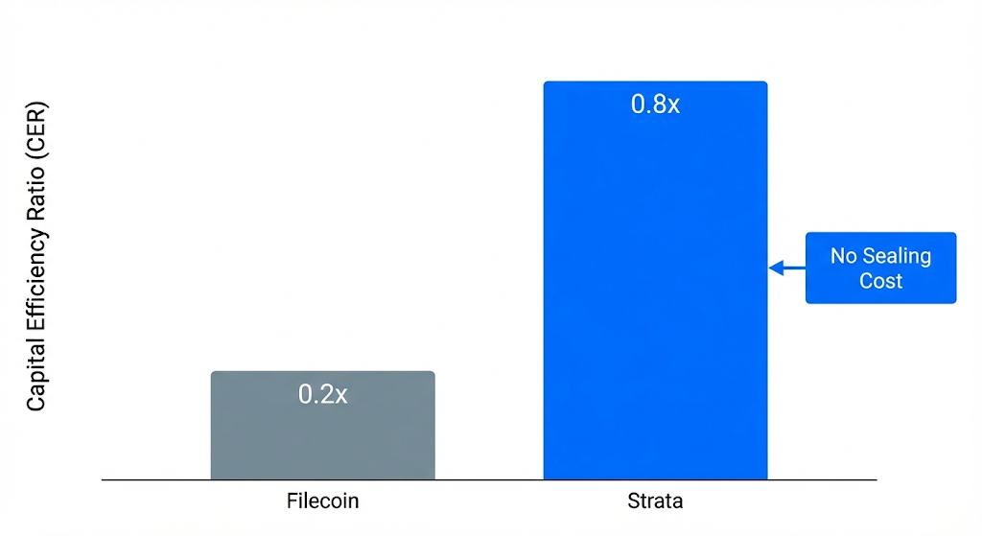Figure 4.5: Capital Efficiency Comparison
4.5.1. The Miner ROI Case Study: Dual-Mining Profitability
To validate the "Yield Stacking" thesis (Section 7.2.1), we model the marginal profitability for an existing storage provider adding Strata to their infrastructure.
- Scenario: A miner with an idle 10 TB partition (already powered on).
- Assumption: The miner purchases the initial $STRAT stake from the open market (Entry Bond).
Table 4.5.1: Projected ROI for a 10 TB Strata Node
Metric | Value | Logic / Notes
1. Hardware CapEx | $0 | Utilization of existing/idle capacity (Sunk Cost).
2. Initial Stake (Entry Bond) | $50 | Purchase of ~$STRAT tokens required to join the active set (Refundable Collateral).
3. Marginal OpEx | $2 / Month | Minimal electricity increase due to lightweight Reed-Solomon encoding (No GPU sealing).
4. Gross Monthly Revenue | $20 / Month | Projected Block Rewards + Data Credit Fees (at 30% network load).
5. Net Monthly Cashflow | +$18 / Month | (Revenue - OpEx). Positive cash flow from Month 1.
6. Stake Break-Even Period | ~2.8 Months | Time required to earn back the cost of the Entry Bond.
7. First-Year ROI | ~330% | (Annual Net Profit / Initial Stake).
Analysis: unlike legacy networks requiring 12-18 months to recoup hardware costs, a Strata Dual-Miner achieves a Break-Even on Stake in under 90 days.
- The "Free Option": After Month 3, the miner is effectively printing "free" yield on hardware that was previously depreciating.
- Stake Appreciation: The ROI calculation above excludes potential price appreciation of the staked $STRAT token. If the token price rises due to the "Liquidity Vortex," the effective ROI increases further.
4.6. Strategic Allocation & Emission Schedule
The allocation is optimized for scarcity to support a $30M raise at a strategic valuation.
Total Supply: 1,000,000,000 $STRAT
4.6.1. Distribution Cap Table
- Investors (20%): Sold to strategic partners (Tier 1 & 2) providing DePIN/Bitcoin liquidity.
  - Seed / Strategic: Valuation range $30M - $80M.
  - Public Sale: FDV $150M. (Creating immediate upside for early backers).
- Mining Rewards (35%): Reduced allocation due to "Recycled Revenue" model.
- Ecosystem & Liquidity (25%): Aggressive Market Making budget.
- Team & Contributors (20%): Subject to a 12-month Hard Cliff followed by 4-year linear vesting.
  - Commitment: No team tokens are liquid until Year 2. This strict lock-up schedule ensures the founding team is fully aligned with the long-term solvency of the protocol, preventing any "rug-pull" risk during the volatile bootstrap phase.
4.6.2. The Emission Decay Schedule
Table 4.6.2: Emission Decay Schedule
Phase | Emission per Epoch | Logic
Bootstrap (Year 1) | 100 $STRAT | High rewards to incentivize "Vampire Attack" migration.
Growth (Year 2) | 80 $STRAT | Balancing growth with initial revenue generation.
Decay Phase 1 (Year 3-4) (Year 3-4) | 50 $STRAT | First supply shock. Network expected to be revenue-positive.
Maturity (Year 5+) | < 25 $STRAT | Protocol relies primarily on recycled revenue (Liquidity Vortex).
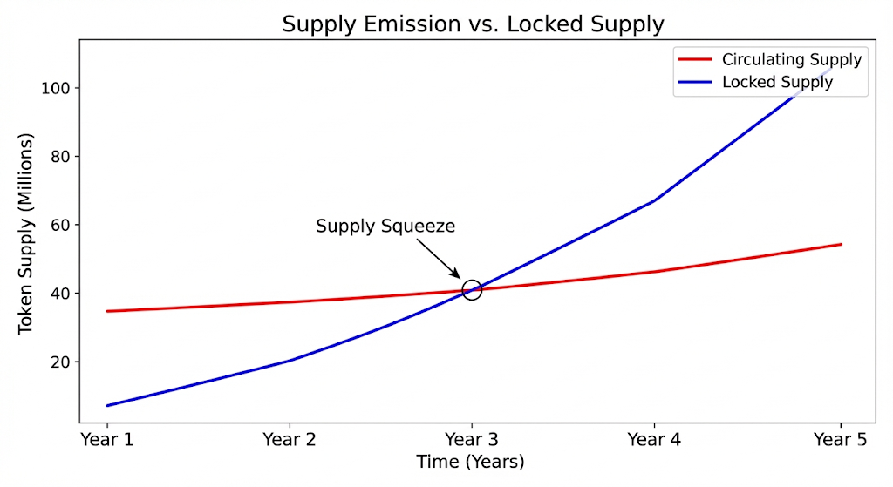
Figure 4.6: Supply Emission vs. Locked Supply

4.6.3. Net Emission Analysis: The "Float Control"
While the Year 1 Emission schedule appears aggressive to incentivize miner migration, the Earn-to-Stake mechanism (Section 4.4.2) acts as a powerful dampener.
- Gross Emission: ~100M $STRAT (Year 1).
- Automatic Lock-up: ~70% of rewards are programmatically captured in Collateral Vaults.
- Net Floating Emission: Only ~30M $STRAT enters circulation.
Conclusion: The market absorbs only ~30% of the headline inflation. Combined with the "Bootstrap Liquidity Loop" (Section 7.2.3), the protocol is engineered to maintain a favorable Supply-Demand ratio even in the pre-revenue phase.
4.7. The Revenue Architecture & Pricing Strategy
Strata Protocol’s monetization model is not arbitrary; it is engineered based on a Structural Cost Advantage that legacy decentralized networks cannot replicate. We monetize the entire data lifecycle—from storage (retention) to usage (retrieval)—creating a diversified, recurring revenue stream.
4.7.1. The Three-Pillar Revenue Stream
Unlike "Cold Storage" networks that monetize only static capacity, Strata captures value from the high-velocity data demands of the Intelligence Age.
- Capacity Lease Fees (Storage):
  - Mechanism: Enterprise clients pay for data retention based on volume and duration ($/GB/Month).
  - Currency: Paid in Data Credits (DC), pegged to fiat to ensure budgetary stability for institutional clients.
- Egress & Bandwidth Fees (Retrieval):
  - Mechanism: Clients pay for data retrieval and bandwidth consumption.
  - Strategic Importance: In the AI era, data is read more often than it is written. Training LLMs requires constant fetching of datasets. This creates a high-margin Recurring Revenue layer that grows with the usage of the stored data, distinct from static storage fees.
- Execution & Settlement Fees:
  - Mechanism: Transaction fees paid to Validators for processing ZK-Proofs, state transitions, and bridging assets via Hyperlane.
4.7.2. The Pricing Logic: Structural Cost Advantage
Our baseline pricing of ~$4/TB/Month is strategically positioned to undercut Web2 incumbents while maintaining healthy protocol margins.
- The "Sealing" Arbitrage:
  - Competitors like Filecoin rely on Proof-of-Replication, which requires expensive GPUs and massive RAM to "seal" data. Their current pricing (~$5/TB) is artificially subsidized by token inflation, as their hardware OpEx often exceeds revenue.
  - Strata Advantage: By utilizing Reed-Solomon Erasure Coding and lightweight zk-PoSt, Strata eliminates the "Sealing" overhead. Our base cost of production is estimated at $1.00 - $1.50 per TB.
  - Result: At $4/TB, Strata generates a >60% Gross Margin from Day 1, whereas competitors operate at a loss to gain market share. This allows Strata to win the price war sustainably without diluting token holders.
4.7.3. Value-Based Pricing for Tier-1 Data
While commodity data utilizes the baseline pricing, Strata applies Value-Based Pricing for "Existential Data" (Section 5.4).
- Price Inelasticity: Clients storing Real-World Asset (RWA) deeds or Bitcoin L2 ledgers are price-inelastic. The cost of data loss (Bankruptcy) far outweighs the cost of storage.
- The "Sovereign Vault" Tier: For these clients, Strata offers a premium tier ($6 - $10/TB/Month) which guarantees:
  - Higher Redundancy: (e.g., 40/10 Sharding schema vs. standard 30/10).
  - Priority Anchoring: More frequent Bitcoin checkpoints.
  - Geo-Specificity: Guarantees data resides in compliant jurisdictions.
- Impact: This segmentation elevates the protocol’s Average Revenue Per User (ARPU) over time as the network reputation matures.
- SLA with On-Chain Insurance: Unlike competitors offering "best-effort" storage, Strata’s "Sovereign Vault" tier includes a decentralized insurance wrapper. A portion of network slashing penalties flows into a dedicated Solvency Pool. In the theoretically impossible event of data loss, smart contracts automatically execute payouts to affected Tier-1 clients, providing a financial guarantee backed by the network’s aggregate stake.
4.7.4. The Cash Flow Engine (Value Accrual)
All revenue collected from the streams above is programmatically funneled into the Liquidity Vortex (Section 4.2).
- Buyback Pressure: 100% of Protocol Revenue is used to purchase $STRAT from the open market.
- Deflationary Impact: 50% of purchased tokens are burned, permanently reducing supply.
- Investor Thesis: As protocol revenue grows from $5M (Year 1) to $90M (Year 3), the mathematically guaranteed buy-pressure creates a floor for the token price, decoupling it from broader market volatility.

SECTION 5: MARKET THESIS & USE CASES
5.1. The Bitcoin L2 Crisis: Plugging the Multi-Billion Dollar Leak
The Existential Threat: The "Bitcoin Renaissance" (Ordinals, BRC-20, L2s) has created over $5 Billion in value, but it is built on a Security Lie.
- Current Bitcoin L2s cannot afford to store data on Bitcoin Core ($4M/MB).
- The Dirty Secret: Most claim to be "Bitcoin L2s" but actually store their transaction history on centralized servers or multisigs. This creates a $5B+ Honey Pot for hackers. If the data server goes down, the entire L2 freezes, and user funds are trapped.
Strata’s "Kill Shot": The Only Native Solution
Strata does not just "store files." We provide Sovereign Insurance for Bitcoin L2s.
- The Mechanism: Strata acts as the off-chain "Extension Block" for Bitcoin. We verify data availability and anchor the proof to Bitcoin L1.
- The Value: We enable L2s to be mathematically honest. They can finally claim "Secured by Bitcoin" without going bankrupt.
- Market Implication: Strata becomes the Standard Compliance Layer. Any Bitcoin L2 not using Strata (or equivalent Bitcoin-DA) will be viewed as "High Risk" by institutional capital.
5.2. The AI "Model Collapse": The Truth Layer
The Existential Threat: The AI industry is rushing toward a cliff called "Model Collapse."
- As AI models begin training on AI-generated content (synthetic data loops), their intelligence degrades.
- Furthermore, in a world of Deepfakes, Provenance is Power. Financial institutions cannot deploy trading bots if they cannot audit the source of the data used to train them.
Strata’s "Kill Shot": The Immutable Supply Chain
Strata is not a cloud drive; it is a Cryptographic Notary for the Intelligence Age.
- Traceability: Every dataset on Strata has an unalterable on-chain lineage. We differentiate "Organic Data" (Human-made) from "Synthetic Data" (AI-made).
- The Alpha: We are building the infrastructure for "Clean Data Markets." Just as consumers pay a premium for organic food, AI Labs will pay a premium for verified, immutable datasets stored on Strata to prevent Model Collapse.
- Performance Thesis: The "Hot Storage" Edge AI Training is I/O intensive, not just storage intensive. A major bottleneck in decentralized storage is the latency of retrieving shards from distributed nodes.
  - Strata's Solution: We implement a "Predictive Caching" layer via our Retrieval Nodes (Edge Accelerators).
  - Mechanism: Using on-chain signals, Edge Accelerators pre-fetch and reconstruct popular datasets (e.g., Llama 3 weights, Common Crawl updates) into NVMe caches located geographically close to the AI Lab’s compute clusters.
  - Result: Strata delivers "S3-like" throughput for hot data while maintaining "Cold Storage" pricing for the underlying archive, solving the Training Latency dilemma.

5.3. The RWA "Link Rot": Saving Wall Street from Itself
The Existential Threat: Wall Street is tokenizing Treasuries and Real Estate (BlackRock's BUIDL fund). However, they are committing a fundamental architectural error: "Hard Asset, Soft Storage."
- A $100M Tokenized Building is worthless if the legal PDF deed is hosted on a Google Drive link that expires or gets hacked ("Link Rot").
Strata’s "Kill Shot": Thermodynamic Finality
We sell Permanence.
- The Pitch: "Institutional Thesis: One does not store a gold bar in a cardboard box. Why secure a $100M token on an AWS server?"
- The Standard: Strata introduces "Bearer Asset Storage". The data is as immutable as the token itself. This is the missing requirement for the Mass Adoption of Tokenized Securities.
5.4. The "InfoFi" Layer: The Immutable Knowledge Graph
The Existential Threat: The Ephemeral Nature of "Alpha" In the fast-paced crypto economy, valuable intelligence ("Alpha") is fragmented across ephemeral Web2 platforms like X (Twitter), Discord, and Governance Forums.
- The Risk: This data is transient and censorable. If a key governance discussion on Discord is deleted, or a seminal research thread on X is banned, the historical context is lost forever.
- The Gap: AI Trading Agents require massive, unbroken datasets of historical sentiment and governance history to make accurate predictions. They cannot rely on broken links or centralized APIs that rate-limit their learning.
Strata’s "Kill Shot": The Sovereign Bloomberg Terminal We are not just archiving files; we are indexing the world's crypto-knowledge. Strata enables the creation of "Decentralized Kaitos"—unstoppable search engines built on immutable data.
- The Mechanism:
  - DePIN Crawlers: Instead of centralized servers, Strata Nodes run lightweight AI crawlers that index governance forums, whitepapers, and social sentiment in real-time.
  - Permanent Indexing: This unstructured data is processed into a structured Knowledge Graph and stored permanently on Strata.
  - Proof-of-Insight: Similar to the "Yaps" model, curators who upload high-signal research or identify trending narratives are rewarded with $STRAT, creating an on-chain "Marketplace of Truth."
The Alpha: "Context-as-a-Service" for AI Agents
- Legacy Model (Kaito/Arkham): You pay a monthly subscription to access their proprietary database.
- Strata Model: AI Agents pay micro-transactions (Data Credits) to query the public Strata Knowledge Graph via API.
  - Example: An Autonomous Hedge Fund Agent queries Strata to analyze “All governance proposals related to Real World Assets from 2024-2026” to decide on a trade.
  - Result: Strata becomes the Permanent Back-end for the entire Web3 InfoFi sector, turning ephemeral chatter into an investable, immutable asset class.
5.5. The Market Void: Strategic & Existential Data
We categorize the global data market not by file type, but by "Cost of Failure."
Table 5.4: Strategic & Existential Data
Data Tier | Examples | Cost of Failure | Strata's Position
Tier 3: Commodity | User logs, CDN caches, social media img. | Low (Inconvenience) | Ignore (Too competitive)
Tier 2: Business | Website hosting, non-critical app state. | Medium (Revenue Loss) | Secondary Target
Tier 1: Existential | RWA Deeds, AI Weights, Bitcoin L2 Ledger. | TOTAL COLLAPSE (Asset value $→$ 0) | DOMINANT MONOPOLY
Analysis: Strata focuses exclusively on Tier 1 Existential Data. When the cost of data loss is total bankruptcy (e.g., a lost $100M RWA deed), clients are price-inelastic. They pay for Certainty, not capacity. This allows Strata to command "Insurance-Grade" margins.
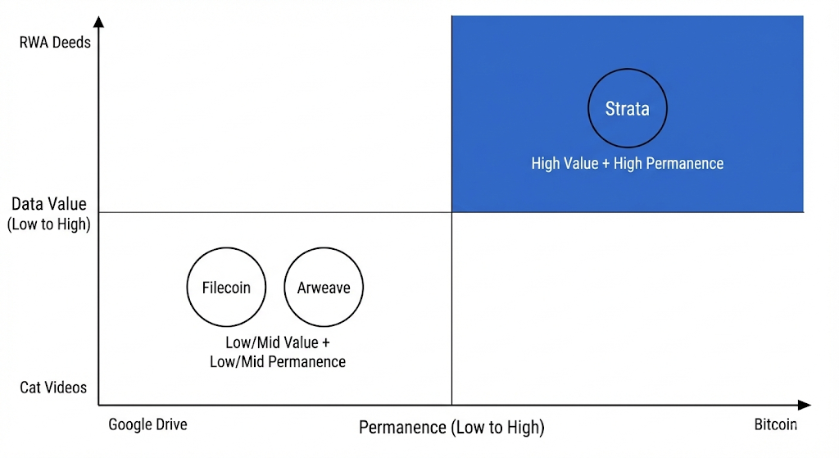
Figure 5.4: The "Blue Ocean" Matrix
5.5. The "Inevitable" Conclusion
The convergence of Bitcoin (The King of Assets) and AI (The King of Computation) requires a missing link: The King of Storage. Existing solutions are either too weak (Multisigs), too expensive (Bitcoin Core), or too disconnected (Filecoin). Strata Protocol is the bridge.
- We borrow Bitcoin’s shield.
- We borrow Celestia’s speed.
- We build the Vault.
Investing in Strata is not a bet on "another storage coin." It is a bet on the structural integrity of the decentralized economy.
The Inevitability of Convergence
The history of computing is the history of specialized decoupling.
- First, we decoupled Money from State (Bitcoin).
- Next, we decoupled Execution from Settlement (Rollups).
- Now, we must decouple Memory from the Machine.
As AI Agents begin to transact autonomously on Bitcoin rails, they require a neutral, immutable record of truth to function. Strata is that record. We are building the Hippocampus of the Global Computer. Investing in Strata is a bet on the structural integrity of the Intelligence Age.

SECTION 6: GOVERNANCE, RISK & COMPLIANCE (GRC)
6.1. Governance Philosophy: The "Checks and Balances" Doctrine
Strata Protocol rejects the naive notion of "Immediate Decentralization" which often leads to governance capture. Instead, we adopt a Constitutional Governance Model modeled after modern corporate governance but enforced via on-chain logic. Our priority is Protocol Solvency and Uptime above all else.
We implement a rigorous system of Checks and Balances between the Executive Branch (The Security Council) and the Legislative Branch (The DAO).
6.2. The Bicameral Architecture
6.2.1. The Legislative Branch: The Token House ($veSTRAT)
- Composition: Comprises long-term stakeholders, who lock $STRAT (1-4 years) to mint vote-escrowed tokens ($veSTRAT).
- Mandate: Responsible for "Budget & Growth".
  - Allocating Ecosystem Grants.
  - Adjusting Inflation Schedules (within hard-coded bounds).
  - Ratifying new Asset Types for storage.
- Safety Mechanism: All successful DAO votes are subject to a 48-Hour Timelock before execution. This allows time for the Security Council to review for malicious code payload or economic exploits.
6.2.2. The Executive Branch: The Security Council
- Structure: A 9-of-15 High-Security Multisig held by doxxed, legally liable entities (Core Devs, Lead Investors, Professional Node Operators).
- Mandate: Responsible for "Security & Stability".
  - Veto Power: Can cancel any malicious DAO proposal during the Timelock window (e.g., a "Governance Attack" attempting to drain the Treasury).
  - Emergency Pauses: Can instantly freeze specific protocol modules (e.g., the Bridge or Minting function) in response to a live hack.
- Sunset Clause: The Council's powers are algorithmically decayed over 4 years. By Year 4, the Council is dissolved and replaced by a fully on-chain elected committee, signaling full maturity.
6.3. Systemic Risk Management (The "Black Swan" Protocols)
We assume that failure is inevitable in complex systems. Therefore, Strata is engineered with Defense-in-Depth layers to survive catastrophic events.
6.3.1. Technical Risk: Invariant-Based Monitoring
We do not rely solely on pre-deployment audits. We implement Real-Time Invariant Checks (Hypernative/Forta integration).
- Mechanism: "Watchtower" bots monitor critical protocol invariants block-by-block (e.g., Total Supply Minted must never exceed Inflation Schedule).
- Automated Response: If an invariant is violated (indicating an infinite-mint bug), the protocol automatically pauses itself without human intervention. This prevents a "LUNA-style" hyperinflationary collapse.
6.3.2. Economic Risk: The Solvency Buffer
- Risk: Extreme volatility causing a cascade of Miner liquidations ($STRAT price crashes $→$ Collateral value drops $→$ Data insecure).
- Mitigation:
  - Dynamic De-risking: The protocol creates an Insurance Fund (funded by 2% of all transaction fees). In a crash, this fund is used to "top-up" compliant miner collaterals, preventing mass evictions of honest nodes.
  - Collateral Smoothing: Collateral requirements are calculated based on a 30-day Time-Weighted Average Price (TWAP), not spot price, smoothing out flash crashes.
6.3.3. Dependency Risk: The "Sovereign Fallback"
- Scenario: A catastrophic failure of the Babylon protocol or a censorship attack on Bitcoin.
- Contingency: Strata implements a "Sovereign Fallback Mode."
  - If Bitcoin anchoring fails for >24 hours, the Strata Validator set automatically reverts to a standard BFT consensus (relying on $STRAT stake only).
  - This ensures 100% Uptime for data retrieval even if the Bitcoin security layer is temporarily severed.
6.3.4. Modular Agility
The "Hot-Swap" Protocol To eliminate "Dependency Lock-in," Strata Governance retains the power to switch underlying providers (e.g., migrating DA from Celestia to EigenDA) via the Module Swapper Contract. The switching speed depends on the trigger event:
- Scenario A: Economic Optimization (Standard Track)
  - Trigger: The external provider becomes economically extractive (e.g., Celestia gas fees exceed a defined threshold, making storage unprofitable).
  - Process: A standard Strata Improvement Proposal (SIP) is submitted.
  - Timeline: 7 Days for Voting + 48 Hours Time-lock.
  - Execution: Upon approval, the DA_Provider_Address parameter is updated on-chain. Nodes have 48 hours to update their clients before the new provider is enforced.
- Scenario B: Catastrophic Failure (Emergency Track)
  - Trigger: The external provider experiences a liveness failure > 4 hours (verified by Oracle).
  - Process: The Security Council (9-of-15 Multisig) declares a "State of Emergency."
  - Timeline: < 1 Hour. The Council executes an instant Emergency_Swap() transaction to route traffic to a Backup Provider (or Sovereign Fallback Mode).
  - Post-Mortem: The DAO must ratify this switch via a retroactive vote within 72 hours; otherwise, the protocol reverts to the previous state.
6.4. Regulatory & Compliance Strategy (The "Firewall")
To attract institutional capital, Strata proactively addresses the regulatory landscape (SEC, MiCA) by separating the Protocol Layer from the Service Layer.
6.4.1. The "Commodity" Classification
We legally structure the $STRAT token as a Digital Commodity (Resource Usage Token).
- Evidence: The token is required to perform physical work (Proof-of-Spacetime). It is consumed/locked to produce a service (Storage). It is not a passive claim on profits (Dividend). This strengthens our defense against "Security" classification under the Howey Test.
6.4.2. The Compliance Gateway (The "Firewall")
While the Strata Blockchain is permissionless, we architect a Compliance Firewall at the Gateway level for Enterprise Clients.
- Strata Enterprise Gateways: Managed Service Providers (MSPs) can run Gateways that enforce KYC/AML and OFAC Screening on data uploads.
- Why this matters: It allows regulated entities (Banks, Hospitals) to use Strata without violating compliance laws, while keeping the underlying blockchain neutral and censorship-resistant.

SECTION 7: ROADMAP & GO-TO-MARKET STRATEGY
7.1. Execution Roadmap: The Path to Liquidity
Our roadmap is structured to prioritize risk mitigation before scale. We align our engineering milestones directly with capital deployment phases to ensure the Token Generation Event (TGE) occurs at the moment of maximum technical maturity.
Phase 1: Foundation & Stealth (Q1 - Q2 2026)
Focus: R&D, Core Engineering, Seed Round Closing.
- Milestone: Complete the Mathematical Formalization of Reed-Solomon & ZK-Circuits.
- Engineering: Launch Devnet v1 (Internal) integrating Babylon Testnet.
- Business: Close Seed Round ($3-5M). Formalize strategic alliances with 3 anchor Bitcoin L2s (Design Partners).
Phase 2: The Incentivized Testnet (Q3 - Q4 2026)
Focus: Supply-Side Aggregation & Stress Testing.
- Milestone: Launch "Strata Wars" (Incentivized Testnet).
- Goal: Onboard the first 1,000 Nodes and test storage of 5 PiB of data.
- Action: Execute "War Games" – paying white-hat hackers to attempt to break the ZK-Verifier and consensus engine.
- Business: Close Strategic Round ($20-30M) based on Testnet metrics.
Phase 3: Mainnet Genesis & TGE (Q1 2027)
Focus: The Liquidity Event & Market Entry.
- Milestone: Mainnet Launch anchored to Bitcoin Block Height #XXX.
- Liquidity Event: Token Generation Event (TGE). Listing on Tier-1 CEXs (Binance/Bybit/Coinbase).
- Operations: Enable the "Vampire Bridge" to migrate Filecoin miners.
- Target: Day 1 FDV (Fully Diluted Valuation) of $150M - $250M.
Phase 4: Expansion & Utility (Q2 2027 onwards)
Focus: Demand-Side Growth & Real Revenue.
- Milestone: Launch Strata Enterprise Gateway (Fiat on-ramp for AI Labs).
- Feature: Activate "Permissionless Bridging" via Hyperlane to Ethereum/Solana.
- Goal: Reach $10M Annualized Revenue (ARR) by end of Year 1.
7.2. Go-to-Market Strategy (GTM)
We solve the classic marketplace "Chicken-and-Egg" problem by decoupling Supply and Demand strategies.
7.2.1. Supply Side: The "Yield Stacking" Strategy (Operation Migrator)
We acknowledge that asking miners to "unplug" from existing networks creates high friction. Therefore, Strata is engineered as a Hardware-Agnostic "Sidecar" Protocol.
- The Logic: Non-Exclusive Mining
Strata nodes are lightweight (due to Reed-Solomon Erasure Coding) and do not compete for the heavy GPU resources required by Filecoin’s Proof-of-Replication sealing process.
  - The Pitch: "Don't turn off your Filecoin miner. Run Strata alongside it on the same idle HDD partitions."
  - Zero Switching Cost: We provide a Dockerized client that runs in the background without interfering with Filecoin operations.
- The Economic Incentive: By dual-mining, operators increase their Revenue Density per Rack by roughly 40% (adding Strata yield on top of Filecoin yield) with negligible increase in electricity OpEx.
- Projected Result: This "Parasitic Growth" strategy allows Strata to absorb 100 PiB of high-quality, enterprise-ready capacity within 90 days of Mainnet launch without requiring miners to buy a single new piece of hardware.
7.2.2. Demand Side: The "B2B2C" Trojan Horse
We do not sell to retail users (creating a Google Drive clone is a losing battle). We sell to Infrastructure Providers.
- Target 1: The Bitcoin L2 Alliance:
  - Partner with Rollup-as-a-Service (RaaS) providers like AltLayer or Gelato.
  - Strategy: Integrate Strata as the default DA option for any new Bitcoin L2 launched on their platforms.
  - Result: Every new L2 brings hundreds of automated paying customers.
- Target 2: The AI "Model Hubs":
  - Partner with Decentralized AI networks (e.g., Bittensor, Gensyn).
  - Strategy: Subsidize storage for high-quality open-source datasets (Common Crawl, Llama weights) to make Strata the "De Facto Library" for AI training.
7.2.3. Phase 1 Demand Strategy: The "Bootstrap" Liquidity Loop
To mitigate the "Cold Start" liquidity risks inherent in early-stage networks (Year 1), Strata deploys a dual-demand mechanism to guarantee baseline buy pressure before organic enterprise revenue fully scales.
- A. Subsidized User Acquisition (The "CAC" Thesis): Rather than distributing free token grants (which creates sell pressure), Strata treats ecosystem incentives as a formalized Customer Acquisition Cost (CAC). The Ecosystem Fund utilizes its stablecoin treasury to purchase $STRAT from the open market, effectively "paying the gas" for strategic partners.
- Mechanism: Purchased tokens are converted to non-transferable Data Credits for partners.
- Financial Logic: This is not "wash trading" but a Deficit Spending Strategy for network bootstrapping—similar to how Uber subsidized rides to build liquidity. It guarantees a baseline buy-pressure floor while creating sticky, organic usage habits among AI Labs and L2s.
- B. The "Stakedrop" Alliance: Leveraging our position as the Data Availability layer for Bitcoin L2s, Strata establishes a "Governance Alignment" program with partner chains.
  - Incentive: Users who stake $STRAT to secure the network are eligible to receive governance token airdrops from the L2s and App-chains utilizing Strata for storage.
  - Behavioral Economics: This speculative utility incentivizes holding and staking behavior during the initial 12 months, effectively removing circulating supply from the market while the network matures.
7.3. Growth Benchmarking & Projections
To validate our $25-40M raise and projected valuation, we benchmark Strata against the growth trajectories of comparable infrastructure protocols.
Table 7.3: Growth Benchmarking & Projections
Metric | Filecoin (2020 Launch) | Celestia (2023 Launch) | Strata (Projected 2027) | Rationale
Year 1 Data Stored | ~500 PiB | N/A (DA focused) | 150 PiB | We target "Quality" (Paid) data, not just junk capacity.
Year 1 Revenue | Low (Subsidized) | ~$2M | $5M - $8M | Higher margins due to "Premium Sovereign Storage" pricing.
Time to Unicorn ($1B) | < 1 Year | < 3 Months | 12-18 Months | Modular Infrastructure + Bitcoin Narrative commands a premium multiple.
Hardware Cost | High (High Barrier) | Low (Light Nodes) | Low | Removal of "Sealing" lowers entry barrier, accelerating supply growth.
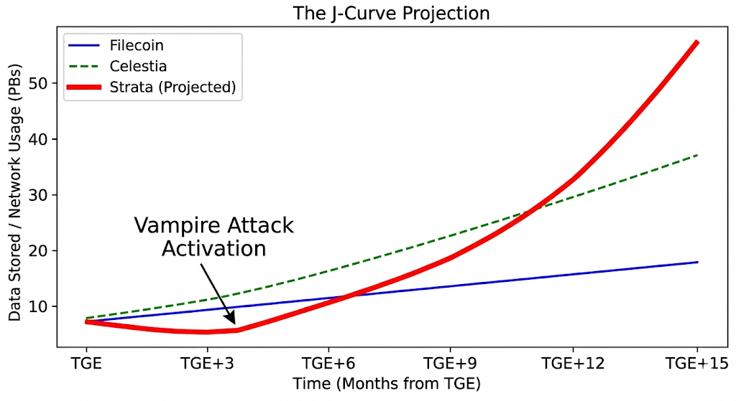
Figure 7.3: Accelerated Growth via Vampire Attack
7.4. Liquidity Management & Listing Strategy
We treat the $STRAT token as a financial product that requires professional structuring.
- Market Making: We will engage Tier-1 Market Makers (e.g., Wintermute, GSR) strictly for liquidity provision, ensuring low slippage for institutional entry/exit.
- Exchange Tiering:
  - Phase A (TGE): List on 2 Tier-1 Exchanges + Uniswap (Curve Pool) to establish price discovery.
  - Phase B (Growth): Strategic listing on Coinbase (US liquidity) once "Commodity" status is legally reinforced via sufficient decentralization metrics (Year 2).
7.5. The Advisory Council & Research Partners
Strata Protocol is architected under the guidance of industry veterans from the intersection of Bitcoin, Modular Infrastructure, and Quantitative Finance.
- Bitcoin Alignment: Advisors contributing to the Babylon and Stacks ecosystems, ensuring our anchoring mechanism adheres to the strict security ethos of the Bitcoin community.
- Mechanism Design: Research partners from top-tier DePIN Foundations, verifying our Proof-of-Physical-Work and Reputation Scoring algorithms against Sybil attacks.
- Cryptoeconomics: Collaboration with quantitative analysts from Tier-1 Market Makers to stress-test the "Liquidity Vortex" model and ensure sustainable token velocity.
- (Note: Full advisory board to be revealed prior to TGE).

SECTION 8: CONCLUSION
8.1. The Investment Verdict: Owning the "Hard Drive" of the Future
We are witnessing the greatest capital rotation in the history of technology. Trillions of dollars are migrating from centralized, opaque intermediaries to decentralized, verifiable protocols.
- Bitcoin won the war for Store of Value.
- Ethereum/Solana are fighting the war for Computation.
- Strata is built to win the war for Memory.
8.2. Why Now? The Convergence Thesis
The timing of Strata is not accidental; it is mandated by the convergence of three irreversible macro-trends:
- The AI Awakening: Autonomous agents require a truth layer that cannot be hallucinated or censored.
- The Bitcoin Renaissance: The world’s most liquid asset class is evolving into a programmable economy, but it lacks a native data layer.
- The DePIN Revolution: Hardware owners are demanding a permissionless way to monetize their idle capacity.
8.3. The Final Word
Strata Protocol is not merely an incremental improvement on decentralized storage; it is a structural necessity for the Intelligence Age. We have engineered a system where security is thermodynamic, scalability is modular, and value accrual is mathematical.
We are not asking you to invest in a "storage coin." We are inviting you to own the index for the preservation of human and machine intelligence.
The vault is open. Welcome to Strata.

APPENDIX
A. Glossary of Terms
- Blobstream: A bridge protocol that enables the streaming of data availability commitments from Celestia to other chains (formerly Quantum Gravity Bridge).
- EOTS (Extractable One-Time Signature): A cryptographic primitive used to punish double-signing validators by leaking their private keys.
- NMT (Namespaced Merkle Tree): A tree structure that allows nodes to download only the data relevant to a specific application ID.
- Thermodynamic Finality: A security state where reversing a transaction requires expending energy equivalent to reorganizing the Bitcoin Proof-of-Work chain.
- zk-PoSt (Zero-Knowledge Proof of Spacetime): A cryptographic proof verifying that a storage provider is storing specific data over a specific period without revealing the data itself.
B. Academic References
- Al-Bassam, M., et al. (2019). LazyLedger: A Distributed Data Availability Ledger with Client-Side Validation. (Foundational paper for Celestia).
- Tas, E., et al. (2022). Babylon: Reusing Bitcoin Mining Power for POS Security.
- Groth, J. (2016). On the Size of Pairing-based Non-interactive Arguments. (Basis for Strata's ZK circuits).
- Reed, I. S., & Solomon, G. (1960). Polynomial Codes over Certain Finite Fields. Journal of the Society for Industrial and Applied Mathematics.
- Buterin, V. (2021). Endgame. (Discussing the roadmap for modular blockchains and data availability).
C. Adaptive Consensus & Circuit Breakers
To ensure 100% liveness regardless of Bitcoin’s state, Strata implements a Finite State Machine (FSM) for consensus switching.
- Condition: If the Time Since Last Anchor ($T_{delta}$) exceeds 6 hours (due to Bitcoin congestion or Babylon downtime).
- Action: The network triggers State_Transition(SOVEREIGN).
- Logic: The Fork Choice Rule temporarily shifts from "Heaviest Bitcoin Work" to "Heaviest $STRAT Stake" (BFT Consensus).
- Recovery: Once Bitcoin liveness is restored, a Batch_Commit re-anchors the accumulated sovereign blocks, merging the security models seamlessly.

